

Newsletter ~ June 2023

~~~June Gala Concert~~~
Often the vibrance of an organization can be demonstrated by the quality of its calendar offerings. The Chatham Music Club presents an impressive array of musical events for your pleasure and inspiration.
This month will feature the winners of our Scholarship Competition held each spring! Congratulations are extended to all participants, their teachers and families with our full and warm wishes for your continued studies in music! We look forward to celebrating your successful performances on June 25th and beyond!

FIRST PRIZE:
Xuanyu Genie Chang, piano. Age 16 – Geraldine Boles, teacher. Exchange student from China. Falmouth Academy.

SECOND PRIZE:
Thomas Marchio, guitar. Age 16 – Jim Skinger, teacher. Monomoy High School, grade 10.

THIRD PRIZE:
Christopher Marchio, piano. Age 14- Anne F. Perrault, teacher. Monomoy High School, grade 8.

HONORABLE MENTION:
Florence Carlson, violin. Dan Flonta, teacher. St. John Paul Prep. School, grade 7.
Ester Huang, piano. Anne F. Perrault, teacher. Barnstable Intermediate School, grade 6.
Sophia Rollo, violin. Dan Flonta, teacher. Barnstable Intermediate School, grade 7.
Isaiah Woodland, flute. LeeAnn McKenna, teacher.

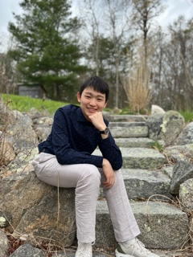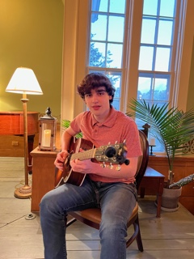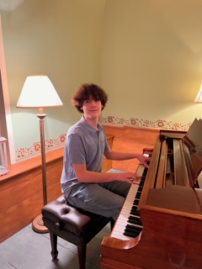
Xuanyu Genie Chang Thomas Marchio Christopher Marchio

GRATITUDE extended to our Panel of Adjudicators:
Lucy Banner, Roy Campbell, Carole Maloof, Anne F. Perrault, Barbara Reed, Matthew Scinto, Jim Skinger.
We hope to share their success with you at:

THE GALA! – ‘Classical Masters”
June 25th, 2023 – 3:00 p.m.
St. Christopher’s Episcopal Church, 625 Main Street, Chatham
ADMISSION: $25
RECEPTION following concert
CONTACT: 508-945-2832 (St. Christopher’s)
www.chathammusicclub.com
~~~~~
August 9th, 2023 – 7 p.m. One hour summer evening organ concert!
Matthew Dion, Organ Recital
St. Christopher’s Episcopal Church, 625 Main Street, Chatham
Free will donations accepted.
~~~~~

There is no delicate way to frame this. Plainly, our dear colleague, and friend, Chris Allen needs our help to Fund his life’s breath. Read on..

My name is Frederic Allen, aka Chris. After a career as a classically trained singer, I found a new calling as a registered nurse. For 25 years I have cared for and helped patients and families in the hospital, at home and in hospice. I am now retired, and I have a rare, fatal lung disease called Idiopathic Pulmonary Fibrosis (IPF).

Now I am the one who needs financial help to pay for treatment.

Three years ago, my breathing felt different. Playing tennis and bicycling became difficult, my breathing felt tight and restricted. A pulmonologist told me that I "probably" had IPF, that it progresses slowly and to call them if it gets worse. Well, it did get worse!

After moving to Connecticut in 2021, my symptoms worsened. I eventually found a pulmonologist who ordered comprehensive testing that confirmed IPF and revealed that severe lung damage had occurred.

Facts about IPF:
- IPF is fatal. Life expectancy is often 4 to 5 years.
- Medical science does not have a clear understanding of the process and causes of IPF (Idiopathic). There is no known cure.
- Treatment options are limited.
- IPF causes impaired lung function (processing oxygen), compromising multiple body functions.
- IPF significantly reduces the quality of life.

SEE: www.nhlbi.nih.gov

A lung scan showed that I still have healthy lung tissue, which made me a suitable candidate for a specialty medication OFEV (Nintedanib) that could decelerate the advance of this uncurable disease as long as the medication is taken continuously.

My Medicare D insurance plan agreed to cover the extreme cost of OFEV for one year, requiring an out-of-pocket copay at $1750.00 a month, which was much more than I could afford. Fortunately, my healthcare provide secured a grant to cover my copayments for 5 months. I started OFEV in late December 2022. When the grant runs out the end of May 2023, I do not know if additional financial assistance will be available. Financial aid is challenging to obtain in the current environment.

In receiving OFEV, I am monitored closely to evaluate effectiveness and am part of a dedicated support program. OFEV has been tested in major clinical trials and is approved as a primary, effective treatment for IPF. Continuous treatment with OFEV is required to slow the disease progression. The benefit in taking OFEV has given me hope that I can take care of myself, maintain quality of life and involvement with my community, and not die prematurely.

I am seeking to raise $22,000.00 (cost for one year of OFEV), so I can pay for the medication if insurance and financial assistance will not cover the cost.

I am so grateful that you have read my story and will consider making a donation. Thank you.
DonateShare

RESPONSE from our Steering Committee:
Hi Everyone,
Our dear tenor and friend, Chris Allen needs our help. Chris has severe pulmonary fibrosis and the specialist has put him on a very expensive drug. The drug is unaffordable for Chris, and without it, he may only live for a few years. Chris has been a wonderful contributor to the CMC. He was Vice President for many years, writer of the Newsletter, and we all enjoyed his beautiful tenor voice at our many recitals and concerts. At our last Board meeting, the directors expressed their desire to help Chris market his go-fund-me page. It has not been easy for Chris to seek help, but he definitely needs it. You can listen to Chris as he explains his situation on his go-fund-me page. (Please scroll down for the link to listen and donate:
https://gofund.me/60d32234)

