“Sing For Life”
A Choral Sing Sponsored by the Chatham Music Club to Benefit our Dear Friend & Wonderful Tenor…
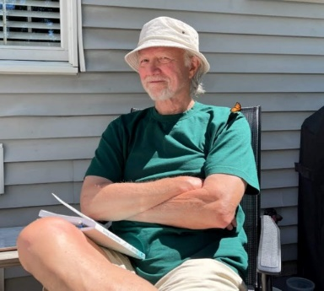

Chris Allen
Saturday, October 28, 2023 @ 2:00 PM
St. Christopher’s Church
625 Main Street, Chatham
Complimentary Reception

Donation $20 or more at the door to pay for life-saving medicine costing $22,000/year! All proceeds benefit Chris Allen. Check payable to Chatham Music Club, Cash or Credit Cards.

Singers & Listeners Welcome!! Popular and Classical Favorites!
Music At The Door. Handicap accessible.
Chris’ Go Fund Me page at https://gofundme/41677ca2 to make a donation.

TO LIFE!!!

