25 Years!**

**Chatham Music Club**

**Hosts**

**Movie Day at the Chatham Orpheum Theater**

**Friday, May 10th at 9:00 AM**

**“AMADEUS”**

**Seniors $9.00/Adults $12.00/Children 13 and under $9.00-Tickets at the Orpheum**

**Refreshments Provided**

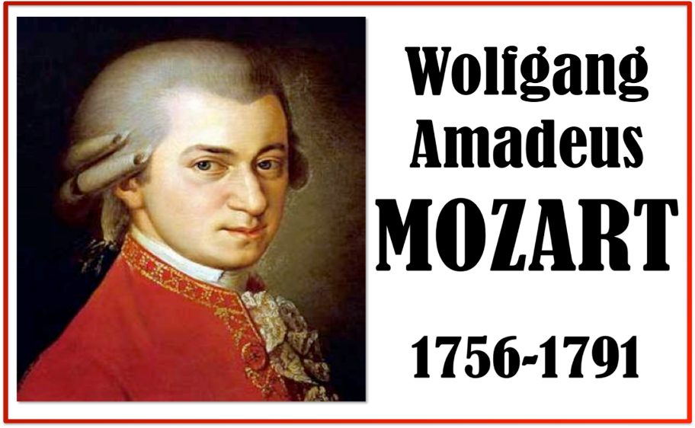

**“Amadeus,” the movie, was made in 1984, but the story begins in 1823 in Vienna. Amadeus is the Latin translation of “loved by God.” Mozart preferred to call himself ‘Amadè.’ The story… the life, successes and troubles of Wolfgang Amadeus Mozart… is told by Antonio Salieri, a contemporaneous composer who was extremely jealous of Mozart’s talent and whose actions lead to a devious scheme that had dire consequences for both men.**

**Come and enjoy this fabulous story about one of the most outstanding and prolific Classical Music composers who lived a brief 35 years! Sip and munch refreshments during the movie. Spend the morning enjoying the music we all love! No reservation is needed…just come! Parking on-street or in the rear lot. Want to know more about the Chatham Music Club and our June 30th Concert “Music of the America’s”…visit** [**www.chathammusicclub.com**](http://www.chathammusicclub.com) **See you at the Movies!**